2018380039_DikshyaKafle Project management practical training

**Assignment 1 Solution:**

**Question NO. 1 Solutions:**

**→ AoN Network:**

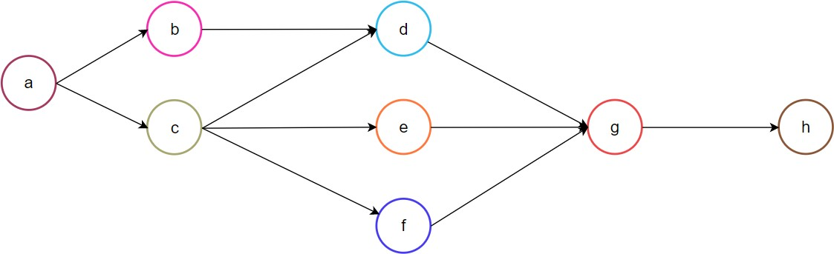

→ **AoA Network:**

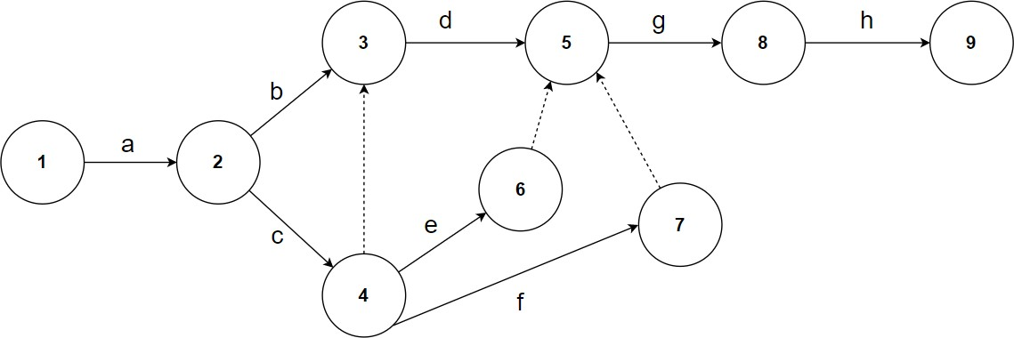

**Question NO. 2 Solutions:**

→ **AoN Network:**

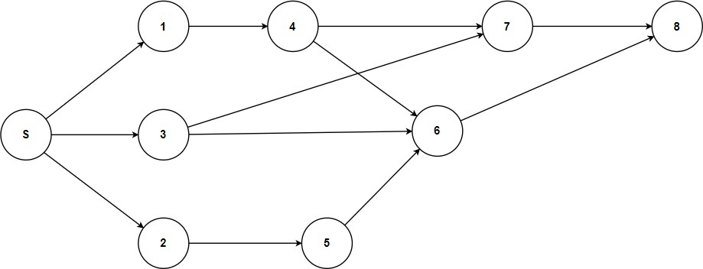

**→ AoA Network:**

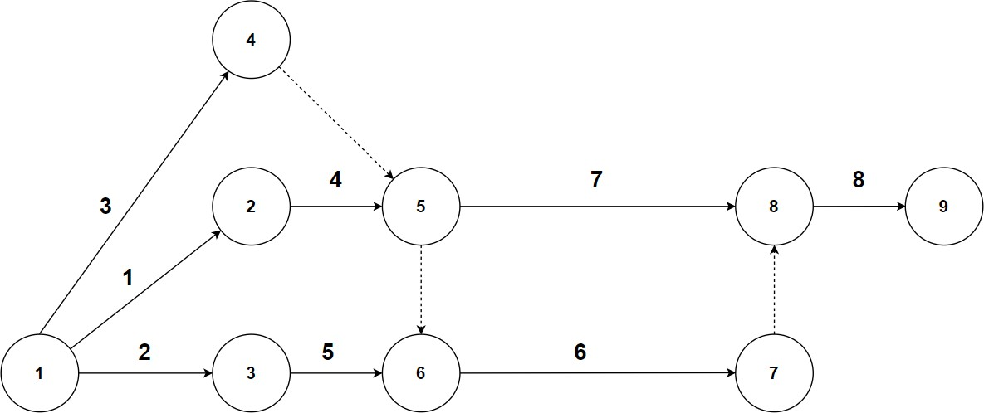

**Question NO. 3 Solutions:**

|  |  |  |
| --- | --- | --- |
| Activity | Immediate predecessors | Duration |
| A | - | 17 |
| B | - | 3 |
| C | - | 20 |
| D | B | 11 |
| E | B | 2 |
| F | B | 12 |
| G | A, D | 7 |
| H | F, C | 2 |
| I | F, C | 10 |
| J | E, C | 6 |

*Where, i = activity, di= duration of activity i.*

|  |  |  |  |
| --- | --- | --- | --- |
| **ESi** | **i** | **EFi** | **TFi** |
| **LSi** | **di** | **LFi** | **FFi** |



6

G:7

A:17

4

D:11

1

8

H:2

11

7

9

J:6

10

5

C:20

F:12

3

B:3 2 E:2

I:10

|  |  |  |  |
| --- | --- | --- | --- |
| 0 | START | 0 | 0 |
| 0 | di=0 | 0 | 0 |

|  |  |  |  |
| --- | --- | --- | --- |
| 0 | B | 3 | 5 |
| 5 | di=3 | 8 | 0 |

|  |  |  |  |
| --- | --- | --- | --- |
| 3 | D | 14 | 9 |
| 12 | di=11 | 23 | 3 |

|  |  |  |  |
| --- | --- | --- | --- |
| 0 | A | 17 | 6 |
| 6 | di=17 | 23 | 0 |

|  |  |  |  |
| --- | --- | --- | --- |
| 0 | C | 20 | 0 |
| 0 | di=20 | 20 | 0 |

|  |  |  |  |
| --- | --- | --- | --- |
| 3 | E | 5 | 19 |
| 22 | di=2 | 24 | 15 |

|  |  |  |  |
| --- | --- | --- | --- |
| 3 | F | 15 | 5 |
| 8 | di=12 | 20 | 5 |

|  |  |  |  |
| --- | --- | --- | --- |
| 20 | H | 22 | 8 |
| 28 | di=2 | 30 | 8 |

|  |  |  |  |
| --- | --- | --- | --- |
| 20 | J | 26 | 4 |
| 24 | di=6 | 30 | 4 |

|  |  |  |  |
| --- | --- | --- | --- |
| 17 | G | 24 | 6 |
| 23 | di=7 | 30 | 6 |

|  |  |  |  |
| --- | --- | --- | --- |
| 20 | I | 30 | 0 |
| 20 | di=10 | 30 | 0 |

|  |  |  |  |
| --- | --- | --- | --- |
| 30 | END | 30 | 0 |
| 30 | di=30 | 30 | 0 |

**Question NO. 4 Solution:**

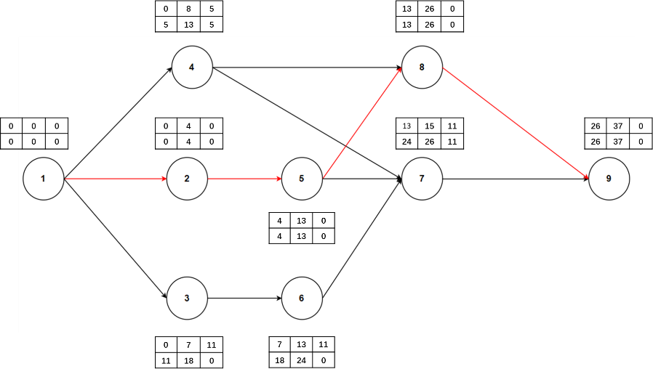

***Where, i = activity, di= duration of activity i.***

|  |  |  |  |
| --- | --- | --- | --- |
| 0 | i=1 | 0 | 0 |
| 0 | di=0 | 0 | 0 |

|  |  |  |  |
| --- | --- | --- | --- |
| 0 | 2 | 4 | 0 |
| 0 | di=4 | 4 | 0 |

|  |  |  |  |
| --- | --- | --- | --- |
| 0 | 3 | 7 | 11 |
| 11 | di=7 | 18 | 0 |

|  |  |  |  |
| --- | --- | --- | --- |
| 0 | 4 | 8 | 5 |
| 5 | di=8 | 13 | 5 |

|  |  |  |  |
| --- | --- | --- | --- |
| 4 | 5 | 13 | 0 |
| 4 | di=9 | 13 | 0 |

|  |  |  |  |
| --- | --- | --- | --- |
| 7 | 6 | 13 | 11 |
| 18 | di=6 | 24 | 0 |

|  |  |  |  |
| --- | --- | --- | --- |
| 13 | 7 | 15 | 11 |
| 24 | di=2 | 26 | 11 |

|  |  |  |  |
| --- | --- | --- | --- |
| 13 | 8 | 26 | 0 |
| 13 | di=13 | 26 | 0 |

|  |  |  |  |
| --- | --- | --- | --- |
| 26 | 9 | 37 | 0 |
| 26 | di=11 | 37 | 0 |